1

**Sardar Vallabhbhai National Institute of Technology, Surat**

***Electrical Engineering Department***



**EPS LAB**

Electrical Engineering Department, SVNIT Surat, 2020-2021

|  |  |  |  |
| --- | --- | --- | --- |
|  |  |  | 2 |
|  | **List of experiment** |  |  |
|  |  |  |  |
| **Sr.** | **Experiment Name** | **Date** |  |
| **No** |  |  |  |
|  |  |  |  |
| 1. | Star/Delta connection of three-phase supply-load through | 19/01/2021 |  |
|  | MATLAB Simulations. |  |  |
|  |  |  |  |
| 2. | Calculation of percentage saving in copper feeder | 02/02/2021 |  |
|  |  |  |  |
| 3. | Calculation of additional load when the system is converted | 09/02/2021 |  |
|  | from dc 2-wire system to ac 3-phase 3-wire system. |  |  |
|  |  |  |  |
| 4. | Calculation of parameters of transmission line using nominal | 16/02/2021 |  |
|  | T and nominal Pi method. |  |  |
|  |  |  |  |
| 5. | Calculation of additional load when the system is converted | 27/02/2021 |  |
|  | from dc 3-wire system to ac 3-phase 4-wire system by |  |  |
|  | addition of a fourth conductor. |  |  |
|  |  |  |  |
| 6. | Calculation of various parameters for medium transmission | 16/03/2021 |  |
|  | line. |  |  |
|  |  |  |  |
| 7. | Calculation of capacitance required in parallel with motor to | 23/03/2021 |  |
|  | raise power factor |  |  |
|  |  |  |  |
| 8. | Evaluation of short and long transmission line. | 6/04/2021 |  |
|  |  |  |  |

Electrical Engineering Department, SVNIT Surat, 2020-2021

3

***EXP NO: 1*- Star/Delta connection of three-phase supply-load through**

***MATLAB Simulations.***

***Aim*:** A 3-ph 230V, 50Hz supply is connected to a 3-ph, 10kW, 0.9 pf (lag) load.

Calculate the line current, phase current, line voltage, phase voltage for:

(a)When supply is star connected and load is also star connected (a)When supply is star connected and load is delta connected (a)When supply is delta connected and load is star connected (a)When supply is delta connected and load is delta connected

Plot all wave forms of active power (p(t)), reactive power (q(t)), voltage (v(t)) and current (i(t)) for line and phase.

***Code/Model Parameters:***

|  |  |
| --- | --- |
| ***Parameters*** | ***Values*** |
|  |  |
| AC supply | 3 phase, 230V |
|  |  |
| Frequency | 50Hz |
|  |  |
| Load | 10kW |
|  |  |
| Power factor | 0.9 (lag) |
|  |  |

***MATLAB Code (.M file):***

**Write Syntax**

V=input('Enter the voltage :');

f=input('Enter the frequency :');

pf=input('Enter the power factor :');

power=input('Enter the power in kw :');

theta = acosd(pf);

I=power*1000/(sqrt(3)*V*pf);

Z=V/I;

R=pf*Z;

Electrical Engineering Department, SVNIT Surat, 2020-2021

4

L=(sqrt(Z*Z-R*R))/(2*3.14*f); wt=0:0.1:(8*pi); %from 0 to 8pi on x v=Vp*cos(wt);

%plot of instantaneous voltage ,current ,P and Q vs wt..

subplot(2,2,1);

plot(wt,v), xlabel('wt'), ylabel('phase voltage'), title('Instantaneous phase voltage vs wt'); z=Z*exp(1i*(pi/180)*(-theta)); i=v/z;

subplot(2,2,2);

plot(wt,ir,wt,im), xlabel('wt'), ylabel('phase current'), title('Instantaneous current vs wt'), legend({'real','imag'});

disp('1) Star-Star or Delta-Star 2)Star-Delta or Delta-Delta')

1. = input('Enter 1 or 2 : '); if c==1

Ip=I;

Il=Ip;

Vl=V;

Vp=Vl/sqrt(3);

disp(Ip);

disp(Il);

disp(R);

disp(L);

ir=real(i);

im=imag(i); pactive=sqrt(3)*(v.*ir); preactive=sqrt(3)*(v.*im); subplot(2,2,3);

plot(wt,pactive) ,xlabel('wt'), ylabel('P'), title('Instantaneous active power');

subplot(2,2,4);

plot(wt,preactive) ,xlabel('wt'), ylabel('Q'), title('Instantaneous reactive power');

elseif c==2

Il=I;

Ip=Il/sqrt(3);

Vp=V;

Vl=Vp;

disp(Ip);

Electrical Engineering Department, SVNIT Surat, 2020-2021

5

disp(Il);

disp(R);

disp(L);

ip=i/sqrt(3);

ir=real(ip);

im=imag(ip);

pactive=v.*ir; %Vp=Vl

preactive=v.*im;

subplot(2,2,3);

plot(wt,pactive) ,xlabel('wt'), ylabel('P'), title('instantaneous active power');

subplot(2,2,4);

plot(wt,preactive) ,xlabel('wt'), ylabel('Q'), title('instantaneous reactive power');

end

**Results:**

Enter the voltage :230

Enter the frequency :50

Enter the power factor :0.9

Enter the power in kw :10

1. Star-Star or Delta-Star 2)Star-Delta or Delta-Delta Enter 1 or 2 : 1

27.8913

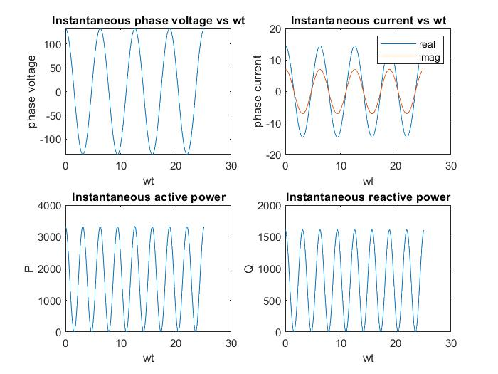

27.8913

7.4217

0.0114

Electrical Engineering Department, SVNIT Surat, 2020-2021

6

Enter the voltage :230

Enter the frequency :50

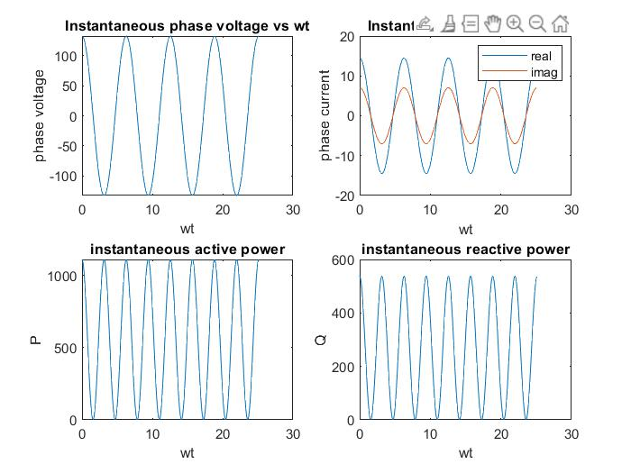

Enter the power factor :0.9

Enter the power in kw :10

1. Star-Star or Delta-Star 2)Star-Delta or Delta-Delta

Enter 1 or 2 : 2

16.1031

27.8913

7.4217

0.0114

***MATLAB Model (.mdl file):***

***Diagram of model:***

**(a)**

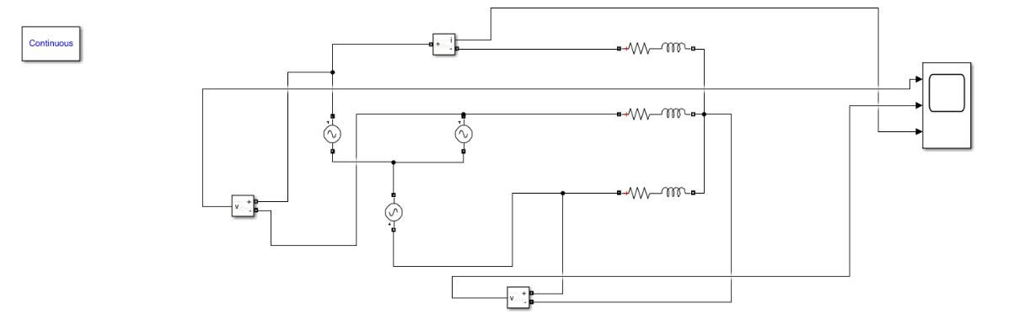

Electrical Engineering Department, SVNIT Surat, 2020-2021

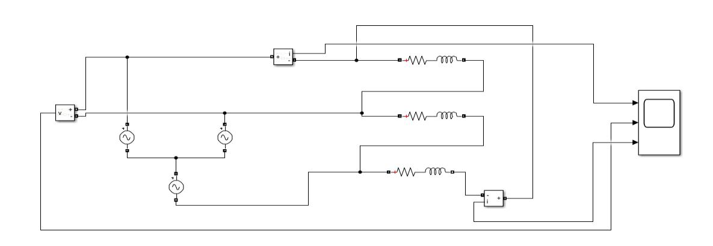7

**(b)**

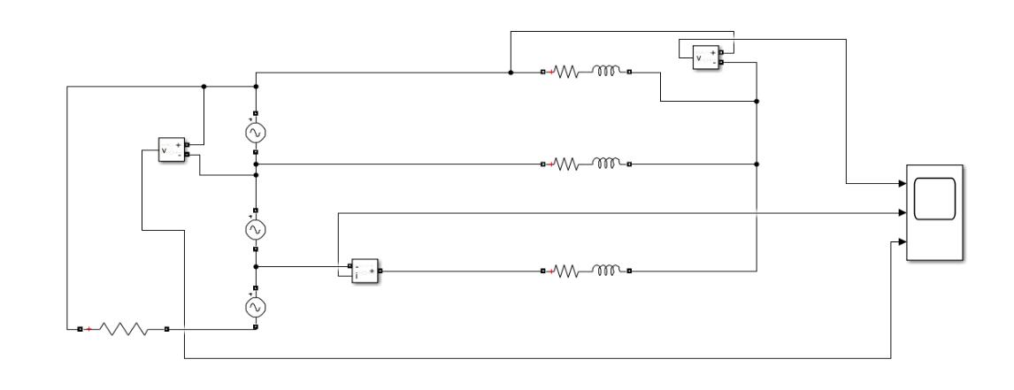

**(c)**

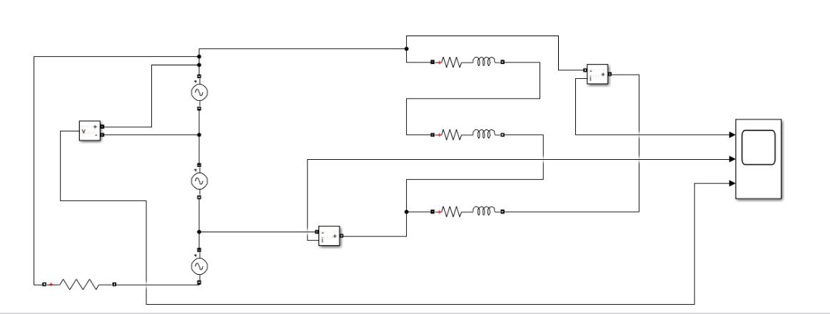

**(d)**

**Results:**

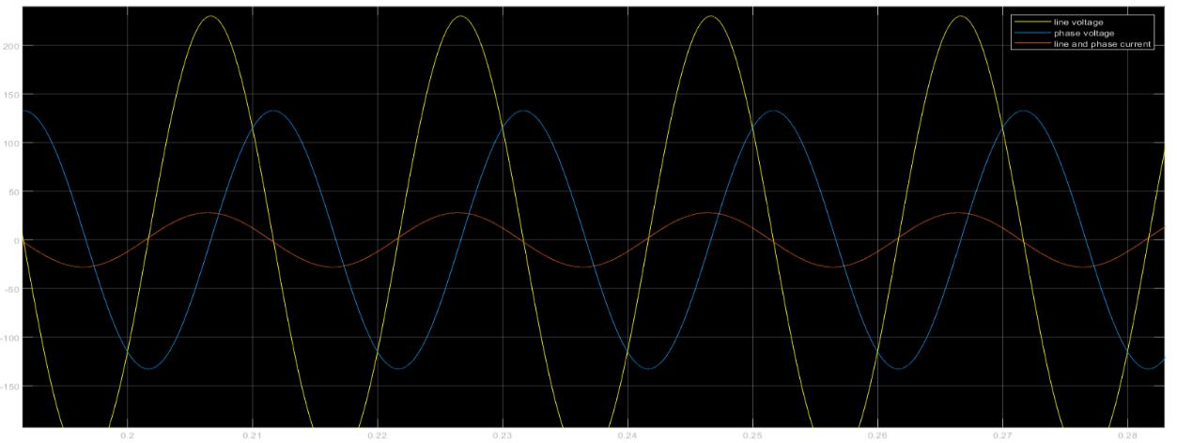

**(a)**

Electrical Engineering Department, SVNIT Surat, 2020-2021

8

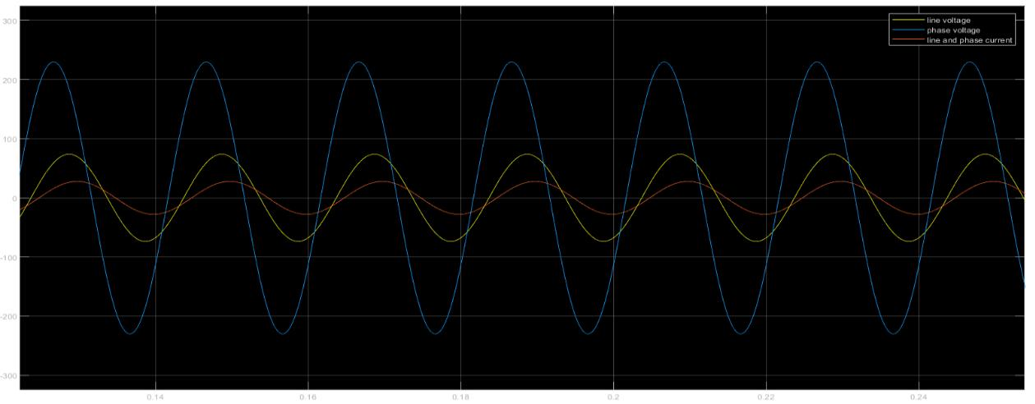

**(b)**

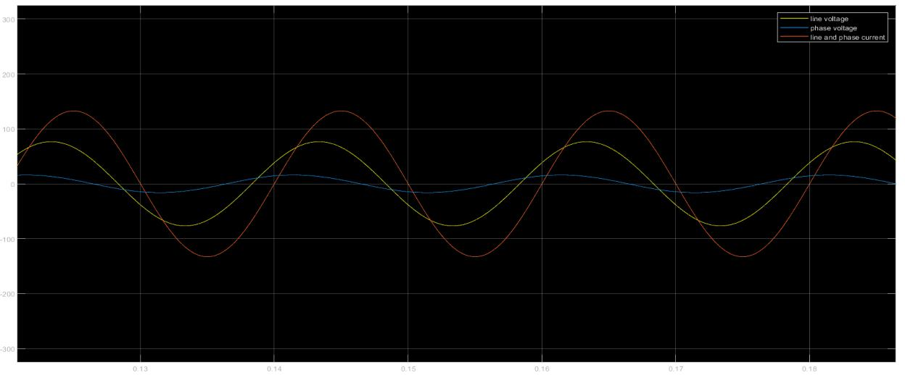

**(c)**

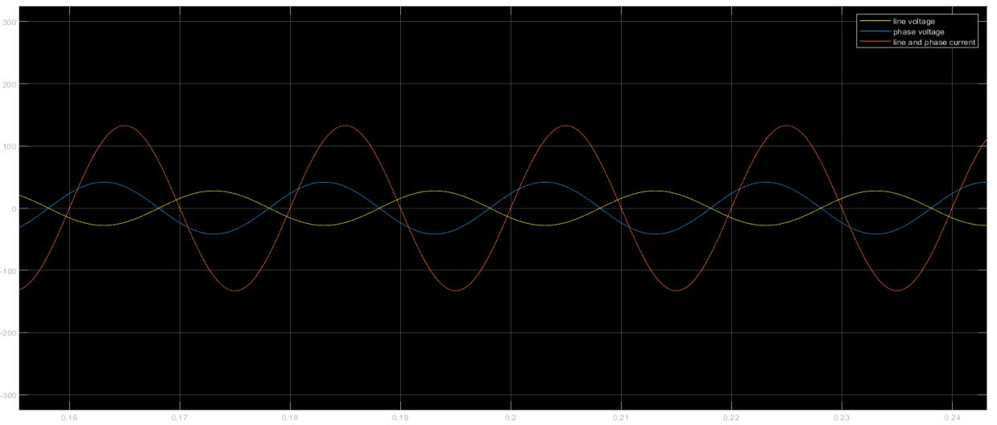

**(d)**

Electrical Engineering Department, SVNIT Surat, 2020-2021

9